

A Project Report
on

STORE LAYOUT OPTIMIZATION

Submitted for partial fulfillment of award of

BACHELOR OF TECHNOLOGY

Degree

In

Computer Science & Engineering
(Affiliated to Dr. APJAK Technical University, Lucknow)
By

SOURYA KUMAR
1422210167

Under the Guidance of
ARCHANA SINGH
(Data Scientist,Sopra Steria)

I.T.S ENGINEERING COLLEGE
GREATER NOIDA

JULY 2017

CERTIFICATE

Certified that SOURYA KUMAR,RAHUL BHAGEL,VIKRANT SHARMA,RISHAV JAISWAL,SAJAL AGARWAL,HIMANSHU JOSHI has carried out the Project work presented in this project entitled “STORE LAYOUT OPTIMIZATION” for the award of Bachelor of Technology degree from Dr. APJAK Technical University, Lucknow under my supervision. The Project embodies result of original work and studies carried out by Student himself and the contents of the Project do not form the basis for the award of any other degree to the candidate or to anybody else.

Date:

ABSTRACT

While bricks & mortar hasn’t had the kind of measurement and continuous improvement systems that drive digital, it has had a long, arduous and fruitful journey to maturity. Store analysts and manager know a lot. And while in-store customer journey measurement can fill in some pretty important gaps, you can do a lot of good store optimization based on a combination of well-understood best practices, basic door-counting, and PoS information. At a high-level, retailers understand how product placement drives sales, what the value of an end-cap/feature is, and how shelf placement matters.
In our project we are making an dashboard for solving the store layout optimization.We are using two data sets one for training the data set and other for Testing the data set.Here we are taking help of R language for developing our software,We had worked on the Shiny app to make the user friendly dashboard.

ACKNOWLEDGEMENT

It gives us a great sense of pleasure to present the report of the Project undertaken during B.Tech final Year. First and foremost We wish to thank our Guide Dr. ASHISH GUPTA( Department of Computer Science and Engineering , I.T.S. Engineering College) for his kind blessings to us . He allowed us the freedom to explore, while at the same time provided us with invaluable sight without which this Project would not have been possible.
We also do not like to miss the opportunity to acknowledge the contribution of all faculty members of the Department for their kind assistance and cooperation during the development of our project.

Sourya Kumar Rahul Bhagel 1422210167 (Roll no.)

Vikrant Sharma Rishav Jaiswal
(Roll no. (Roll no.)

Himanshu Joshi Sajal Agarwal
(Roll no. (Roll no.)

TABLE OF CONTENTS

CHAPTER NO. TITLE PAGE NO.

ABSTRACT 3
ACKNOWLEDGEMENT 4

1. INTRODUCTION 7
2. LITERATURE REVIEW 8
2.1 Conventional Store Layout Retailing 8 2.2 Hybrid Online Retail Layout (HORL) 9
2.3 Implication of Virtual Store Layout 10
3. IMPROVEMENT,PROBLEMS,METHODOLOGY 11
3.1 Implication of Virtual Store Layout 11
3.2 Problems 12
3.3 Methodology 12
4. IMPLEMENTATION AND RESULTS 13

4.1 Implementation to existing system 13
4.1.1 WIFI 13
4.1.2 CCTV 14
4.2 Results 15

5. ADVANTAGES AND DRAWBACK 16
6. CONCLUSION 17 7. REFERENCES 18

List of Figures

Chapter Figure Page No.

2. Figure 2.1 Showing conventional store layout 8
2. Figure 2.2: Showing an example of HORL 9
2. Figure 2.3: Showing an structure of virtual layout 10
4. Figure 4.1: WIFI Analysis 13
4. Figure 4.2: CCTV Analysis 14
4. Figure 4.3: Showing dashboard of the project 15

CHAPTER 1

INTRODUCTION

While bricks & mortar hasn’t had the kind of measurement and continuous improvement systems that drive digital, it has had a long, arduous and fruitful journey to maturity. Store analysts and manager know a lot. And while in-store customer journey measurement can fill in some pretty important gaps, you can do a lot of good store optimization based on a combination of well-understood best practices, basic door-counting, and PoS information. At a high-level, retailers understand how product placement drives sales, what the value of an end-cap/feature is, and how shelf placement matters.
With PoS data, they also understand which products tend to be purchased together. So what’s missing? Quite a bit, actually, and some of it is pretty valuable. With customer journey data you can do true funnel analysis – not just at the store level (PoS/Door Counting) but at a detailed level within the store. You’ll see the opportunity each store area had, what customer segments made up that opportunity, and how well the section of the store is engaging customers and converting on the opportunity. Funnel analysis forever changed the way people optimized websites. It can do the same for the store. When you make a change, you can see how patterns of movement, shopping and segmentation all shift. You can isolate specific segments of customer (first time, regular, committed shopper, browser) and see how their product associations and navigation patterns differ. If this sounds like continuous improvement through testing…well, that’s exactly what it is.
In our project we are making an dashboard for solving the store layout optimization.We are using two data sets one for training the data set and other for Testing the data set.Here we are taking help of R language for developing our software,We had worked on the Shiny app to make the user friendly dashboard.

CHAPTER 2

LITERATURE REVIEW

There are some methods/Techniques to apply an effective store layout management which not only saves the space of the store it also helps the customer to find the product which he is looking for. They are:-

2.1 Conventional Store Layout Retailing
The strategy in store’s layout has significant implication on customer’s behavior on purchase. The problems to decide a fit layout strategy in store rises due to a limited space availability to display all products to provide excellent customer service.
According to Levy & Weitz , store layouts in retailing are conventionally classified into three different layout, grid, free form and racetrack layouts.

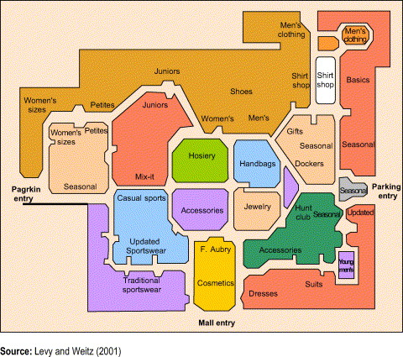
Figure 2.1: Showing conventional store layout

2.2 Hybrid Online Retail Layout (HORL)
The conventional online store layout, to accommodate the disadvantages of applying OSL mentioned previously, a progressive online layouts are required. One of them is called hybrid online retail layout (HORL), which is developed by accommodating each function of conventional store layout. HORL allows customers to choose accessing the stuffs within the store in three different ways based on the customers’ needs.

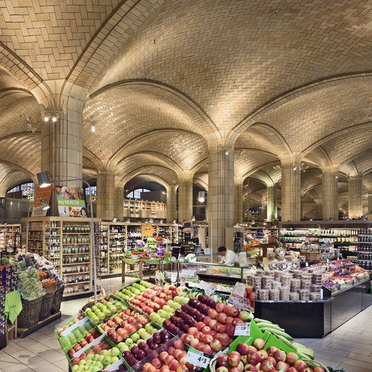
Figure 2.2: Showing an example of HOEL

2.3 Implication of Virtual Store Layout
A significant growths of World Wide Web and internet users have impacted on online business especially on the business to customers Virtual retailers recently use internet not only for display purposes but also for other functions as ordering process and online purchasing process
virtual store layout decisions is potentially giving customers more information needed about the stores and developing customers’ elaboration and response the other products or brands.
A big corporate point of view, the concept of virtual store might become the solution to minimize the costs of supply chain management from the long channel of supply by cutting function of the “real” retailing stores and replacing it into virtual store.
Virtual retailers recently use internet not only for display purposes but also for other functions as ordering process and online purchasing process.The same phenomena in the free form ORL that customers are willing to spend more time in the store for shopping due to enjoy the freedom of move within the store.

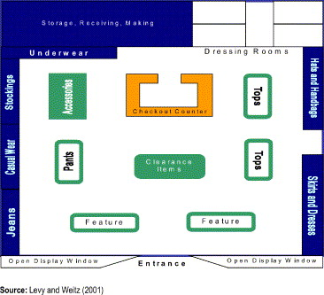
Figure 2.3: Showing an example of Virtual layout

It is believed that the three conventional online store layout such as grid, free form and racetrack has relationship with the customers’ perceived in different ways as customers’ time spent in the website, the willingness to purchase, freedom to move on the website and the level of entertainment.

CHAPTER 3

3.1 IMPROVEMENT TO THE EXISTING SYSTEM

As we know the store layout is rubbish before this any product is placed at any place which
results the selling of that product but now with the help of software we can predict which place is best to increase the sell of the product like we can predict which product has higher selling rate so that we can put it in front so that it is visible to the consumer . We can also predict that what’s the thing with which the item is selling more like butter with bread. In such way we can find out the place or combination of product which are selling more. While before using this product we use the walk through inspection for checking the sale of the product for which we have to hire a man and need more human effort but now the only software is describe all the record of any data which is under observation. The customers coming into their store knowing exactly what they want and where to get it, therefore making a beeline for it. When a customer enters your store, you want to present them with something eye-catching, fresh and interesting. Something that will take their mind off their path towards a specific product and encourage them to stop and interact with your display. Now the thing come what you have to do? So for this Create a doorway display that catches the eye, and gives customers something to interact with.
This doesn’t have to be something elaborate or flashy, and could be as simple as an unboxed product, a flower display, a large poster or even a little table with a few chocolates or edible treats on, as a little gesture of goodwill to your customers. If it makes them stop, think, interact, or catches their eye (See, it works) – you’re doing the right thing. It will also help you to how much time your customer spend in each part of your store, where they stop, and for how long.This will help you optimize your store layout, improve merchandising, enhance promotional offers, predict staff scheduling requirements, highlighting busy and slow time and measure customer waiting time.

3.2 PROBLEM
In this we have to face many problems one of them is we can’t know what the consumer is
actually thinking to purchase and we also don’t know for which item they are looking for and
that will buy the product or not. The place where the product is placed is visible to consumer or not and also is consumer available to pay the amount(MRP) of the product.
To solve the such type of problem we take a data set of a shop and then predict that at which place the movement of the consumers is high and also in which item the consumer is interested .We can identify the customer by using there mobile phone,cctv camera, finger print etc and save the data about that item and customer. One of our recommendations for store designers is to maximize customers’ view of the merchandise by chevroning. Chevroning involves “placing shelves or racks at an angle” instead of shelves being placed at the traditional ninety-degree angle to the aisle. The logic behind the recommendation is that the more merchandise customers’ see, the more merchandise they purchase.

3.3 METHODOLOGY

Several methods have been developed to solve facility layout problems and these can be classified into two broad groups: empirical and theoretical methods. Empirical methods are used to develop initial or potential layouts based on experience and knowledge, evaluate the alternatives with quantitative criteria, and then revise the potential choices to find the optimal facility layout. These methods can be very ad hoc and difficult to apply to larger problems. One example is Pearson who developed a spreadsheet model to evaluate the arrangement of departments in retail stores using empirical methods to create the layout. With theoretical methods, mathematical modeling techniques are commonly applied. In this research, one aspect of the retail store layout problem is modeled as a knapsack problem. For general knapsack problems, exact algorithms have been developed, such as branch-and-bound. Most knapsack problems can be solved by using dynamic programming in pseudo polynomial
time. For more complex knapsack problems, heuristic search methods have been applied successfully.The heuristic algorithms that researchers are most interested in are genetic algorithms, simulated annealing, ant algorithms and other meta- 25 heuristic search methods. Often the use of heuristics is motivated by the difficulty in solving models to optimality. For example, the layout model of Yapicioglu has nonlinear constra.

CHAPTER 4

IMPLEMENTATION AND RESULTS

4.1 Implementation
In stores there are so many devices which is used to record the data of the customer or to record the data of the product.The customer data can be maintained through the NFID,Fingerprint,CCTV,Bluetooth of mobile, WIFI connection on mobile,Billing of shopping,By there movement in the shop,etc.
4.1.1 WIFI /Bluetooth recording
When a customer visits to the store there is no surety that customer is going to buy the product which is available in the store.But we can make a data that what customer is looking for more,There movement can be monitored.Generally customer has their mobile WIFI on or their Bluetooth is on when they enter to the shop.This can be used by the shops to monitor the movement of the customer.suppose a customer is having an mobile IP address XYZ ,his address is stored in the database of the shop.when again this customer comes to the shop they can easily identify that customer and predict that in which product customer is interested in.
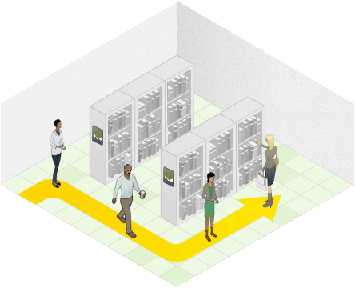
Figure 4.1:Showing the WIFI Traffic analysis

4.1.2 CCTV
Stores has generally the CCTV through which the movement of the customer can be easily located.This can help in analysis the data that which part of the shop is having a great numbers of visitor,the section having a great number of visitors shows that that section is more intresint then the other sections.It also says that there will be more purchasing from that section by the customers.
CCTV can also be used to see the counters status,by help of it we can decide that how many counters should be open.This saves the men work and it also helps in gaining more profits because there will be need of less men power.

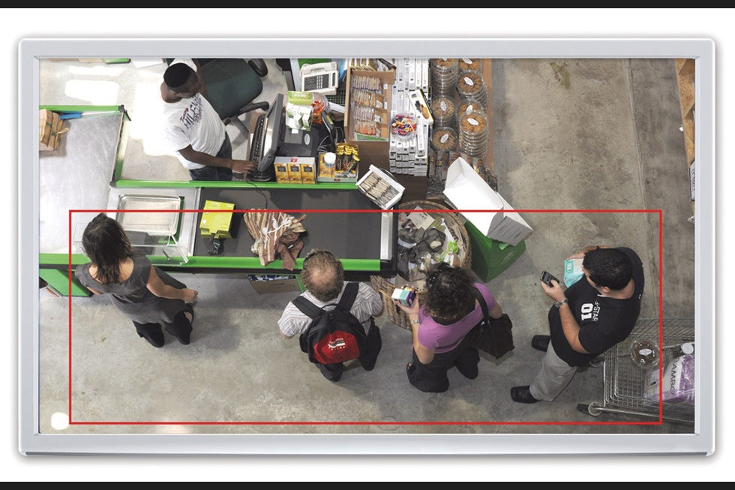
Figure 4.2:Showing CCTV Analysis

4.2 Results
We can use this database to make an data set,And when we analysis this data set we will get the predicted data of the data set,Which can be used to improve the outlet selling, Customer satisfaction,This data set can be analysis by making an dashboard for users and anyone with an good analysis skill can read this for improving the product sales in the shop.
Here we are having a Data set of an retail stock,we are using this data set to make an dashboard for the shop so that they can easily identify their shops data set and can take action for this.we had created the user interface by using which user can direct select some variables and they can use it for them self .

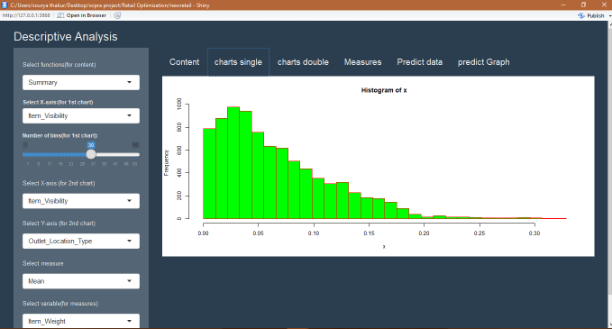

Figure 4.3: Showing Dashboard of the software

CHAPTER 5

ADVANTAGES, DRAWBACKS

5.1 ADVANTAGES
- Can be used to analysis a large data set of an y retail shop.
- Error in the prediction is less.
- No need of remembering the coding,It is having an UI for that.

5.2 DRAWBACKS

- Prediction can be accurate some times.
- Cannot operate on the data set having missing values.

CHAPTER 6

CONCLUSION

At last we had came to an conclusion that with the help of proper analyzing skills and with the help of the software which we had made through a data set,we can predict multiples values.Some values can be used to improve the layout model of the shop,some can be used to improve the products selection,some can used to select offers on the product so that the number of the customer can be incressed to a particular area or section.
We also saw that with the help of some of the gadgets we can monitor the customers location in the shop and we can also predict that which item is bought by the customer more.We can also use this software for the persons who is having only basic knowledge of the computer.Gadgets can store the data of the customers and the product,which can be used by the shopkeepers to provide better facilities to the customer and hence improve the profit of the shop.

CHAPTER 7

References

- https://www.analyticsvidhya.com/blog/2016/02/bigmart-sales-solution-top-20/
- http://archive.ics.uci.edu/ml/datasets/online+retail#
- http://journals.sagepub.com/doi/full/10.1177/1550147717692585
- https://github.com/VasTsak/r-exercises/blob/master/shiny_pt1.R
- Wikipedia
- Google.com
- Youtube.com

